Research article


Neuro-fuzzy controller to accelerate biogas production in a biodigester
Controlador neurodifuso para acelerar la producción de biogás en un biodigestor

Alfredo N. Torres López^{1,2}, Rodrigo Cadena Martínez¹, Martha Hernández Ochoa²

¹Universidad Americana de Europa, Av. Bonampak, Sm. 6, Mz. 1, Lt. 1, Cancún, Quintana Roo, México.
²Universidad de Guadalajara, Centro Universitario del Norte, Carretera Federal No. 23, Km. 191, C.P. 46200, Colotlán, Jalisco, México

Corresponding author: Martha Hernández Ochoa, Universidad de Guadalajara, Centro Universitario del Norte, Carretera Federal No. 23, Km. 191, C.P. 46200, Colotlán, Jalisco, México. E mail: martha.ochoa@cunorte.udg.mx. ORCID: 0000-0002-3464-108X.

Received: April 13, 2026 Accepted: July 9, 2026 Published: July 13, 2026
Abstract. - The anaerobic digestion of domestic organic waste represents a sustainable alternative for renewable energy production through biogas generation. However, the inherently nonlinear and multivariable nature of biodigestion processes limits the effectiveness of conventional control strategies, reducing process efficiency and increasing production times. This study proposes the development and evaluation of an intelligent neuro-fuzzy control strategy aimed at accelerating biogas production in a batch anaerobic biodigester. A dynamic mathematical model of the biodigester was implemented in MATLAB®/Simulink to represent the biological behavior associated with biomass degradation and methane generation. Subsequently, an Adaptive Neuro-Fuzzy Inference System (ANFIS) was designed and trained using process data obtained from dynamic simulations. The controller combined fuzzy logic decision rules with the adaptive learning capabilities of artificial neural networks, enabling automatic adjustment of control actions according to process operating conditions. The control architecture was implemented in a closed-loop configuration to regulate critical variables influencing anaerobic digestion performance. Simulation results demonstrated that the neuro-fuzzy controller significantly improved system stability, reduced dynamic oscillations, and maintained key process variables closer to their reference values. In comparison with open-loop operation, the proposed strategy increased biogas production and reduced the time required to reach stable operating conditions. Furthermore, the controller exhibited a significantly faster response in biogas production, achieving up to 71% improvement in efficiency compared with the open-loop system and reducing the time required to reach equivalent production levels by approximately 70 days, indicating high predictive and adaptive capability. These improvements are attributed to the controller’s ability to compensate for disturbances and continuously maintain favorable conditions for microbial activity and methane production. The findings confirm that the integration of artificial intelligence techniques into biodigester control systems constitutes a viable and promising approach for enhancing anaerobic digestion efficiency, increasing renewable energy generation, and supporting sustainable waste management. Future work will focus on the experimental implementation of the proposed controller using industrial sensors, actuators, and real-time embedded control platforms.
Keywords: Anaerobic digestion; Biogas production; Neuro-fuzzy control; Artificial neural networks; ANFIS; Biodigester; Renewable energy; Intelligent control.

Resumen. -La digestión anaerobia de residuos orgánicos domésticos constituye una alternativa sostenible para la generación de energía renovable mediante la producción de biogás. Sin embargo, la naturaleza altamente no lineal y multivariable de este bioproceso dificulta su operación eficiente mediante estrategias convencionales de control. El objetivo de esta investigación fue desarrollar y evaluar un controlador neurodifuso capaz de acelerar la producción de biogás en un biodigestor anaerobio tipo batch. Para ello, se implementó un modelo matemático dinámico del biodigestor en MATLAB®/Simulink®, representando las principales variables involucradas en la degradación de la biomasa y la generación de metano. Posteriormente, se diseñó un sistema de inferencia neurodifusa adaptativa (ANFIS), entrenado mediante datos obtenidos a partir de simulaciones dinámicas del proceso. La estrategia propuesta integró las capacidades de razonamiento de la lógica difusa con la capacidad de aprendizaje y adaptación de las redes neuronales artificiales, permitiendo ajustar automáticamente las acciones de control ante variaciones en las condiciones operativas. Los resultados obtenidos mostraron una mejora significativa en la estabilidad dinámica del sistema, una reducción de las oscilaciones de las variables críticas y un incremento en la producción de biogás respecto al sistema operando en lazo abierto. Asimismo, el controlador mostró una respuesta significativamente más rápida en la producción de biogás, alcanzando una eficiencia por encima del 71 % en comparación con el sistema operando en lazo abierto. Este desempeño permitió reducir el tiempo requerido para alcanzar condiciones equivalentes de producción en aproximadamente 70 días . Los resultados demuestran que la integración de técnicas de inteligencia artificial en el control de biodigestores representa una alternativa viable para incrementar la eficiencia de los procesos de digestión anaerobia, contribuyendo al aprovechamiento energético de residuos orgánicos y al desarrollo de sistemas sostenibles de generación de energía renovable. El trabajo futuro se centrará en la implementación experimental del controlador propuesto utilizando sensores y actuadores industriales, así como plataformas de control embebido en tiempo real.
Palabras clave: Digestión anaerobia; Biogás; Biodigestor; Control neurodifuso; ANFIS; Lógica difusa; Redes neuronales artificiales; Energías renovables.

- Introduction

Despite the rapid growth of renewable energy, fossil fuels still dominate the global energy mix. Globally, they cover more than 80% of primary energy demand. The vast infrastructure designed for fossil fuel processing creates inertia that slows the transition to renewable energy [1]. The true costs of pollution and climate change are generally not reflected in the final price, distorting competition with clean energy sources.

In this context, renewable energy emerges as a viable and necessary alternative to diversify the energy mix and reduce dependence on conventional sources. Among these sources, biomass stands out for its capacity to utilize organic waste from agricultural, forestry, agro-industrial, and urban activities, which in many cases do not receive adequate treatment and end up generating additional environmental problems [2]. The underutilization of biomass as a renewable energy source, despite its abundance and environmental, social, and economic benefits, highlights the need to analyze and propose strategies to improve its energy use sustainably, thus contributing to the transition to cleaner, more efficient, and more resilient energy systems [3].

One inexhaustible resource is the organic waste generated daily in homes, which in most cases is unsorted. The general idea of ​​this work is to utilize this waste to produce biogas as the primary product and, as a secondary product, organic fertilizer. The biogas can be burned on-site for processes requiring high temperatures or powering an electric generator.

The Guadalajara Metropolitan Area in Jalisco has a population of slightly over 5 million inhabitants, indicating significant potential for generating organic household waste. Most of this waste is not utilized in any way and is deposited directly in the city's various landfills through the sanitary collection system. Much of this organic matter can still be used as biomass with proper decomposition in a digester to produce biomethane and, as a secondary product, fertilizers with high nutritional content. Utilizing this waste aims to promote the recycling of waste materials for energy generation and reduce the effects of pollution.

  - Main points

To optimize biogas production from organic household waste in an accelerated manner, the available biodigester models will be analyzed. The different control systems currently used for biogas production will be investigated. A control model for bioprocesses based on artificial intelligence for nonlinear systems will be developed. Establish performance parameters through simulation. Validate the models through the physical development of the biodigester. Analyze results and plan future work for the utilization of the product and waste.

- Background (Theoretical framework, state of the art)

2.1. Transition to Renewable Energy

The transition to an energy system based primarily on renewable energy sources (RES) is one of the greatest challenges of our time. As it is currently unfolding, it is giving rise to several sometimes-paradoxical situations in the energy sector. While advances in RES technologies in recent years have led to significant cost reductions and substantial growth in installed RES capacity worldwide, CO2 emissions have barely decreased due to lower coal prices and a consequent increase in coal-fired power generation (Figure 1). Similarly, while installed wind and solar capacities in some European countries have grown phenomenally, the cost of electricity production from these sources has risen rapidly to levels comparable to those of traditional sources [4].

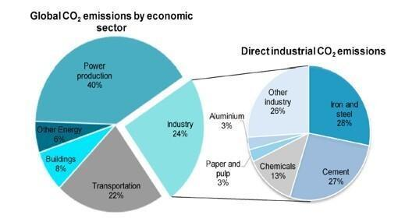
Figure 1. CO₂ Global emissions from 2014 [5].

Energy is essential for modern society to maintain our accustomed standard of living and to ensure the smooth operation of other elements of the economy. Reliance on technology and higher living standards result in increased energy demands, which in turn increase the consumption of fossil fuels, leading to ozone depletion and environmental problems [6] . All of this poses a greater risk to the health of all living beings. Figure 1 graphically illustrates how various productive sectors have contributed to global CO2 emissions [7].

2.2. Biomass

Biomass represents the main renewable source of biogas and other biofuels, making it a highly viable alternative to the inevitable depletion of fossil fuels[8]. Biogas can be economically converted to methane in facilities ranging from small-scale utility equipment for farmers to large-scale equipment in urban plants, thus making it possible to meet regional and national energy demands. In general, biogas has better quality than natural gas and has a much lower potential to pollute the environment [9] .

2.3. Biogas Production

Biogas plants act as essential tools for sustainable waste management, using proven technology that can manage excess organic materials previously considered waste, while simultaneously generating clean, renewable energy and enabling material recovery through organic fertilizers [10]. Biogas is a mixture primarily of methane and carbon dioxide, formed during anaerobic digestion (AD) along with a residual mixture known as digestate. Digestate retains macro- and micronutrients from the feed and is rich in nutrients such as nitrogen, potassium, and organic carbon, which promote soil health [11] . Biogas can be converted into biomethane, which can be used to replace natural gas and injected into gas networks, thus increasing energy independence at both the local and national levels [12].

AD is one of the methods for recycling agricultural byproducts and converting them into energy sources for immediate use AD involves the microbial decomposition of organic materials, which are metabolized into biogas (methane) in an environment devoid of bound or free oxygen [13]. Biogas production in AD occurs in four stages: hydrolysis, acidogenesis, cytogenesis, and metallogenesis [14]. AD is one of the most effective biological methods for waste treatment, converting agricultural waste products into bioenergy sources. Other advantages of AD include low biomass generation, the ability to treat large organic loads, and the production of stabilized sludge [15]. Furthermore, the digestate remaining after biogas production can be an important source of fertilizer. The energy generated in AD can be used as biogas, heat, fuel, gas, etc. Typical biogas can consist of up to 75% methane and 25% carbon dioxide by volume, with an energy content of around 35,846 kJ/m³ [16].

Biogas is produced in plants through the bacterial degradation of biomass under anaerobic conditions. There are three categories of biomass: (1) agricultural substrate (manure and crop residues); (2) domestic and municipal waste (organic waste separation and wastewater treatment); and (3) industrial byproducts such as glycerin, food processing byproducts, or grease separator residues [9]. The organic matter is converted into biogas by bacteria in several steps within sealed digesters. The bacteria are similar to those found in the forestomaches of ruminants. Certain basic conditions must be met to allow the bacteria to efficiently degrade the substrate. These are: (1) absence of air (anaerobic atmosphere); (2) uniform temperature; (3) optimal nutrient supply; and (4) optimal and uniform pH [17]. The equipment in a biogas plant must be capable of meeting these basic requirements; therefore, it is very important to know what type of substrate will feed the plant in order to select the equipment for efficient biogas production. Biogas production methods can be characterized by the number of process steps, the process temperature, the dry matter content, and the way the substrate is fed [18] .

2.4. Bioprocesses

The concept of a bioprocess can be situated within the concept of Biotechnology: “Biotechnology is the use of living organisms or parts of them to obtain a product or service useful to humans.” A bioprocess is “a process that involves methods from chemical engineering to biotechnological processes”. An appropriate containment system is then required to develop metabolic activity; that is, an ideally controlled micro-ecosystem that allows the organisms to carry out their activity properly [19].

Bioprocess can be defined as the cultivation of cells or the use of cell components in a bioreactor (BR), capable of creating an optimal growth environment or utilization of cellular material. In bioprocesses, then, cells (microbial, animal, and plant) and cell components, such as enzymes, are used to manufacture new products or destroy hazardous waste [20].

Requiring a controlled environment, bioprocess consists of a series of steps involving the use of living organisms to create any useful product or service [21].

2.5. Expert Systems and Artificial Intelligence

Human intelligence allows us to understand the concept of control regardless of academic background. For example, if a person is told to maintain a constant temperature (say, 78°C) in a process and is given a "knob" to manipulate the energy level entering the system, a device displaying the current temperature is sufficient for the person to quickly understand that adjusting the knob can modify the process temperature (Figure 2), even in the presence of disturbances.

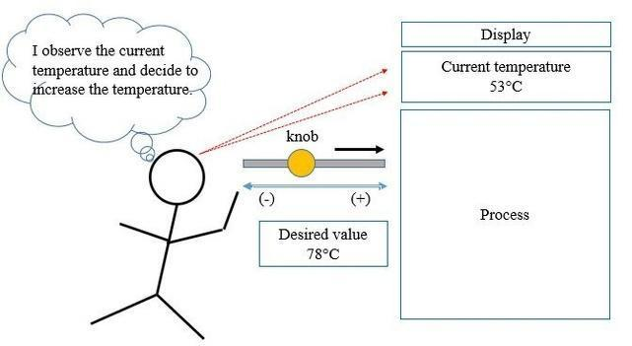
Figure 2. Manual temperature control of a process, self-made.

If this same person's sole task is to perform this action, over time they will gain experience and their control will become increasingly faster and of higher quality, resulting in increased efficiency and precision.

When adjusting and controlling one variable modifies the value of another of equal importance, and if the system contains many such variables, it becomes virtually impossible to model the system with a moderate degree of uncertainty. Ideally, machines would "understand" the environment and the specifications necessary for the desired product development, just as a person would, without needing a reliable and, ideally, simple mathematical model. Artificial intelligence (AI) studies these possibilities [22]. AI models itself on the intelligent functionalities of human beings, emphasizing the desire to approximate human behavior and thought processes for solving specific problems. AI aims to stimulate the development of novel, efficient, and better-planned solution methods [23]. AI is a term coined in the mid-20th century, around the 1960s at the Massachusetts Institute of Technology (MIT). The fundamental topics of AI encompass several areas of study, the most common and important of which are: solution search, expert systems, natural language processing, pattern recognition, robotics, machine learning, logic, uncertainty, and fuzzy logic. The arrival of digital computers in the early 1950s allowed for a shift from speculation to a genuine theoretical and experimental approach to AI [24].

Consequently, AI is thriving as a practical discipline in areas where expert knowledge is needed without relying on common sense. The availability of machines with vast computing and storage capacity has increased the possibility of directing empirical research toward the physical symbol system hypothesis. In each investigation, a particular task is selected for resolution, and a program is proposed to execute it and verify the results. The scientific trend indicates that these problems will eventually be overcome by programs more sophisticated than those currently available.

2.6. Fuzzy Logic

One of the main strengths of digital systems is their logical simplicity, since the flow of information is based on the knowledge of two states: high and low. The description of the operations and characteristics that can be performed requires a binary system (0, 1). It is "simple" for machines to "understand" this information since they are either on or off. Based on this logic, programming languages ​​were developed, requiring that all states be finite and completely defined, free of ambiguities [25].

However, the common, natural language we humans use to communicate and transmit knowledge is full of ambiguous terms and uncertainties. This is because dialogues take place within a specific context.
In general, biological intelligence endows us with a "great" ability to recognize patterns, allowing us to understand unclear or fuzzy concepts. In the field of AI, these fuzzy concepts are called fuzzy. We can distinguish other people even if they have dyed or cut their hair, shaved, or grown a beard; we can even recognize a voice when someone is sick or there is a lot of noise.

The goal of AI is for machines to understand the environment and the specifications necessary for process control just as a person would, without needing a mathematical model. Then why involve mathematical terms? While humans have sufficient cognition, machines do not. Machines are still on-off devices; therefore, they require unambiguous values ​​to execute tasks. These values ​​will be obtained precisely from the mathematical functions involved. The central idea is that the functions should be as simple as possible, a set of constants and straight lines in most cases.

There are four main functions used to represent fuzzy sets. Their names come from the graphs they typically form: Z-function, Delta (Δ) function, Pi (Π) function, and S-function. Figure 3 shows the typical forms of these membership functions [26].

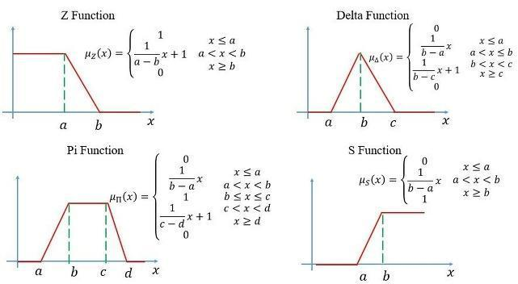
Figure 3. Membership functions for fuzzy sets, own elaboration.

As many fuzzy sets as desired can be developed for a given variable; the more sets, the greater the degree of precision, but the complexity of implementation also increases. The process of determining fuzzy sets is called fuzzification [27].

Any plant must have input signals to process and generate output signals (response). Since the signals are information about the physical variables, it is possible to fuzzify them and attempt to obtain a relationship through empirical rules based on expert knowledge to bring the responses to the desired values. These rules will have the conditional form "if...then...".

Machines only understand conventional logic, so they require clear terms. Therefore, it is necessary to bring the fuzzy input and output variables to a single, unambiguous, or clear value, which is called defuzzification. Defuzzification consists of applying a mathematical expression that somehow combines the results of the membership functions of the linguistic variables to obtain a single value that the machine can interpret.

2.7. Artificial Neural Networks (ANNs)

ANNs are defined as nonlinear mapping systems whose structure is based on principles observed in the nervous systems of humans and animals. They consist of a large number of simple processors linked by weighted connections. The processing units are called neurons. Each unit receives inputs from other nodes and generates a simple scalar output that depends on the available local information, stored internally or received through the weighted connections [23].

A neural network is characterized by the following elements [24]:

1. A set of processing units or neurons.
2. An activation state for each unit, equivalent to the unit's output.
3. Connections between the units, generally defined by a weight that determines the effect of an input signal on the unit.
4. A propagation rule, which determines the effective input of a unit based on external inputs.
5. An activation function that updates the new activation level based on the effective input and the previous activation.
6. An external input that corresponds to a term defined as a bias for each unit.
7. A method for gathering information, corresponding to the learning rule.
8. An environment in which the system will operate, with input signals and even error signals.

A neural network combines several processing layers (Figure 4) and uses simple elements that operate in parallel, inspired by biological nervous systems. It consists of an input layer, one or more hidden layers, and an output layer. The layers are interconnected by nodes, or neurons; each layer uses the output of the previous layer as input [28].

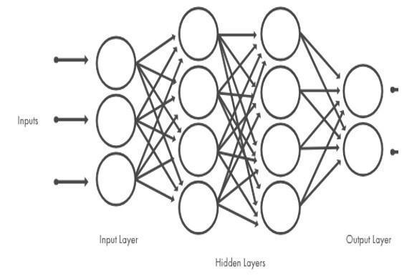
Figure 4. Architecture of an ANN [28].

An artificial neuron has an internal state called the activation level, which, when processing the signals it receives, allows it to modify its own state. Activation states can be discrete values ​​of two or more elements and can even be continuous intervals. Figure 5 shows a model to represent the above idea. It has a set of inputs corresponding to the synaptic signals of a biological neuron. Each signal is modified by an associated weight before being applied to the adder, which represents the neuron's cell body [29].

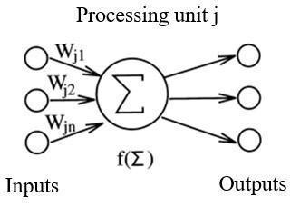
Figure 5. Diagram of a typical artificial neuron. [29]

The inputs are represented by a set of signals $\vec{X}=\left\{x_{1},x_{2},x_{3},x_{4},…,x_{n}\right\}$, each receiving a synaptic connection strength $\vec{W}=\left\{w_{1},w_{2},w_{3},w_{4},…,w_{n}\right\}$such that $E=w_{1}x_{1}+w_{2}x_{2}+w_{3}x_{3}+…+w_{n}x_{n}$. In a compact form using linear algebra, this can be expressed as: $E={\vec{X}}^{T}\vec{W}$[28].

Signal E is processed by the activation or output function $S_i$. Depending on the model used, this function can be:

- Linear. $S=KE$, where $K$ is a constant
- Threshold. $S=1$ if $E≥θ$ and $S=0$ if $E<θ$; where $θ$ is the constant threshold.
- Arbitrary. $S=F\left(E\right)$; where $F$ is any function.

Neural networks are self-adaptive dynamic systems due to the self-adjusting capacity of the procedural elements (neurons) that make up the system [30]. They are dynamic because they are capable of constantly changing to adapt to new conditions. In the learning process, the weighted links of the neurons are adjusted to obtain specific results, without the need for an algorithm to solve a problem, since the network can generate its own weight distribution in the links through learning. The designer's role is solely to obtain the appropriate architecture [31].

A neural network must learn to calculate the correct output for each input constellation (array or vector) in the set of examples. This learning process is called the training or conditioning process. Learning is the process by which a neural network modifies its weight in response to input information. The changes which occur during this process are limited to the destruction, modification, and creation of connections between neurons, which means that the weight of each neuron takes on a non-zero value.

The learning scheme of an artificial neural network (ANN) determines the type of problem it will be able to solve. Learning an ANN consists of determining the precise weight values ​​for all its connections. The general learning process involves gradually introducing examples from the learning set to check if a certain convergence criterion has been met. If not, the process is repeated to adjust the weights until the criterion is met within a certain tolerance level, or until a certain number of cycles have been completed, or until the weight modifications become insignificant [29].

- Methodology

Given the characteristics of the work to be carried out, a quantitative methodology will be primarily used to analyze the physical phenomena involved through the dynamics described by mathematical models. The numerical information generated by the models will be analyzed to evaluate the results and generate comparative tables that validate the efficiency of the proposed algorithms.

The first step is to review the existing literature in scientific articles, books, and other research works related to biogas production from biological byproducts. Likewise, in parallel, the documentation related to the development of control algorithms based on fuzzy logic and neural networks that may be applicable to this work will be reviewed.

The second step consists of reproducing the existing proposed mathematical models to determine which one best adapts to the conditions and resources available for this research, through simulation with different operating points.

Once the model to be used has been defined, the third step will be to determine the performance specifications necessary to establish the optimal reference levels with which the proposed intelligent control algorithms should be trained. As a fourth step, the results will be validated to make the corresponding modifications to the algorithms until a satisfactory response is obtained, that is, an absolute deviation of less than 15% from the desired parameters.

Provided that available economic resources and time allow, the final step will ideally involve the physical implementation of the plant and the control system to compare the results obtained through modeling with real-world data.

The fossil fuel consumption generates electricity and/or heat for industrial and domestic processes resulting in an increase in emissions of polluting gases. This has incentivized many industrialized countries to develop clean and renewable energy generation projects. In this context, one of the sources with the greatest potential is the use of biomass to produce biogas with sufficient energy output to meet diverse needs [32].

The time required for biomass decomposition and biogas production can range from 60 to 90 days using conventional process control techniques, as shown by some experimental results [33].

Using fuzzy logic algorithms with neural networks, the aim is to accelerate production by increasing the biomass while maintaining constant temperature and humidity, as well as a regulated pH to encourage the reduction of oxygen present in the process, thereby increasing the decomposition rate and decreasing production time and bioprocess efficiency.

A bioprocess can be defined as the cultivation of cells or the use of cell components in a bioreactor (BR), capable of creating an environment for the optimal growth or use of cellular material [20].

Therefore, an appropriate containment system is required to develop metabolic activity; that is, a controlled micro-ecosystem that allows microorganisms to perform their activity properly [19].

The implementation is proposed to be carried out in the following order:

¬ Bioreactor modeling
¬ Open-loop model validation through simulation
¬ Controller development using machine learning
¬ Closed-loop system simulation to verify the response

3.1 Bioreactor Modeling

A bioreactor is defined as the container where a reaction catalyzed by microorganisms (biomass) and/or enzymes takes place in a controlled environment.

The process in the bioreactor can be aerobic or anaerobic depending on the type of microorganism and whether it requires the presence or absence of oxygen. It can be continuous or batch, depending on the loading and unloading of the substances [34]. For our case study we have a batch anaerobic reactor, figure 6.

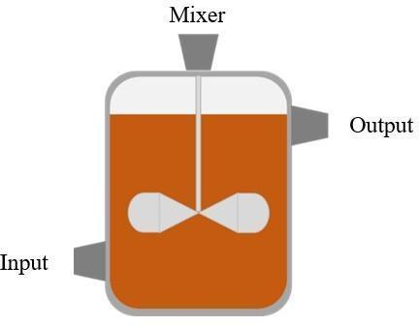

Figure 6. General scheme of batch reactor, own elaboration.

A batch reactor, meaning it is closed, there is no continuous inflow or outflow. Furthermore, to approximate a uniform reaction rate throughout the reactor, a mixer is included, which simplifies the model. Biomass growth occurs through the consumption of appropriate nutrients (substrates) under favorable environmental conditions [35].

Dynamic models are used to describe what happens in a bioreactor. In the simplest mathematical model, at least two components are required [36]:

Substrate ($S$): the organic component that serves as food for the biomass.

Biomass ($X$): the culture of heterotrophic microorganisms that feed on biodegradable organic matter. Its concentration can be measured by the concentration of volatile suspended solids (VSS).

The substrate and biomass are related by a set of two nonlinear differential equations:

$$\frac{dS}{dt}=D\left(S_{i}-S\right)-Yμ_{S}X (1)$$
$$\frac{dX}{dt}=D\left(X_{i}-\left(1-η\right)X\right)-μ_{S}X (2)$$
Where:

$D$: Dilution factor $d^{-1}$ represents the influent volumetric flow rate per unit volume of the reactor (inverse of the hydraulic residence time).
$S_{i}$: Substrate concentration in the inlet [mg/L COD].
$Y$: Substrate performance coefficient [mg COD/mg VSS].
$μ_{S}$: Bacterial growth model.
$X_{i}$: Biomass concentration in the inlet stream [mg/L VSS].
$η$: Sedimentation efficiency (SLG).
In simplifying the model, acidogenesis and methanogenesis are considered a single process, which assumes that bacterial growth follows the kinetics for enzyme-catalyzed processes:
$$μ_{S}= μ_{max}\frac{S}{K+S}$$

Where: $μ_{max}$: Maximum rate of the biological process $d^{-1}$.
$K$: Half-saturation constant for the substrate [mg/L COD].
Open-loop model validation through simulation

In an anaerobic digestion process for biogas production, the variable to be manipulated must be the regulation of organic matter (biomass) in the effluent, despite any fluctuations in the inlet composition. In fact, volatile fatty acids (VFAs) can accumulate, causing undesirable effects by altering the acidification operating point (pH) and leading to overall operational failure. Therefore, the model must include an adequate description of two fundamental stages: acidogenesis and methanogenesis [37]. For the purposes of this study, the description of both stages is represented in a single process for simplification.

The fact that many variables are involved in a bioreactor introduces a high degree of complexity to obtain an accurate model, especially when the aim is to obtain a simple model, in addition to considering the nonlinearities of the system.

For this reason, the only variables are taken into account described in the model represented by equations (1) and (2), whose open loop model which is built in Simulink ® Matlab can be seen in figure 7.

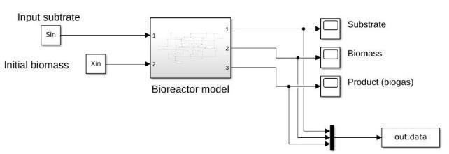
Figure 7. Batch reactor modeling in Simulink® Matlab open loop, self-made.

The following shows the biogas production behavior in an open-loop batch bioreactor using the previously established model. The objective is to compare the performance of the neuro-fuzzy controller with respect to the biogas production rate. The simulation data are shown in Table 1 results section.

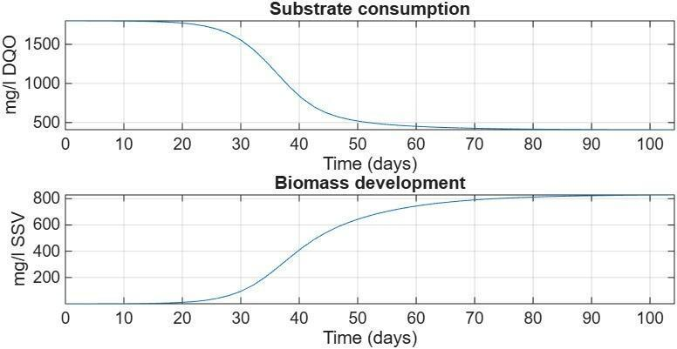
Figure 8. shows the open-loop dynamics of the substrate and biomass.

It can be observed that the biomass begins to feed and reproduce, evidenced by the reduction of the substrate, until it reaches an equilibrium point around day 90, where biogas production stops, allowing the substrate residue to be converted into bio-fertilizer.

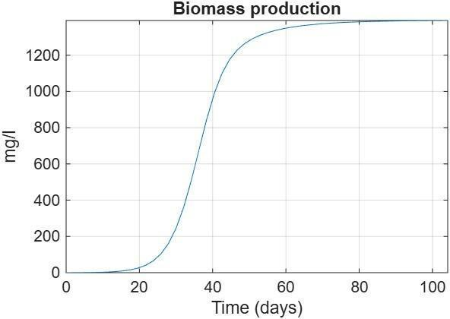
Figure 9. Open loop biogas production, own elaboration.

Therefore, all the energy consumed by biomass is assumed to be biogas production, that is, the expected output, which is shown in Figure 9.

3.2. Development of the neuro-fuzzy controller using machine learning

Since the aim is not to add further complexity to the system, a proportional control action is chosen as the starting point for the training model for the neuro-fuzzy controller [38], due to its simplicity. This is based on the author's own experience, as shown in Figure 10.

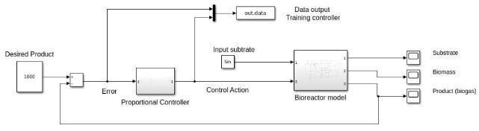
Figure 10. Closed-loop batch reactor modeling in Simulink® Matlab for training purposes, self-made

The proportional controller gain is modified until empirically obtained product data meets the desired performance requirement, i.e., show an acceleration in biogas production compared to the open-loop model (less than 90 days). With the error information and the control action, the neuro-fuzzy controller is trained using Matlab's Neuro-Fuzzy Designer, as shown in Figure 11.

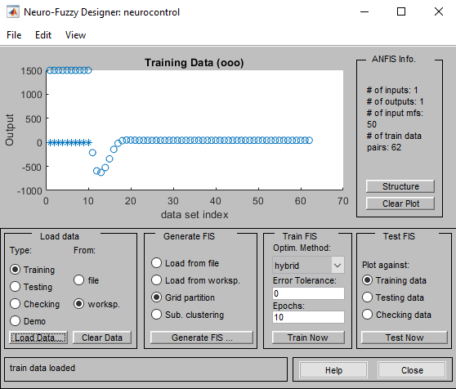

Figure 11. Data loading into the Simulink Matlab neuro-fuzzy designer (author's own work).

The number of associated fuzzy sets for the fuzzy controller is established since a "large" number of sets increases the accuracy of the result, as shown in Figure 12.

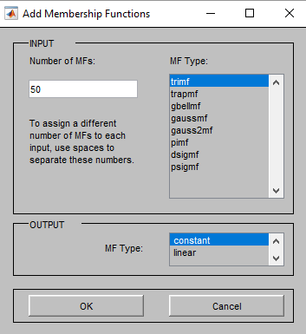
Figure 12. Loading membership functions into the Simulink® Matlab neuro-fuzzy designer (author's own work).

Immediately afterward, the controller was trained with 10 iterations, resulting in an absolute error of 0.0025067, as shown in Figure 13.

It should be noted that various tests were performed, which are not shown here due to the limitations of this work. These tests involved modifying the quantity and type of fuzzy sets, as well as the number of iterations, but the absolute error results did not show a significant variation compared to the chosen method, although the simulation time did increase.

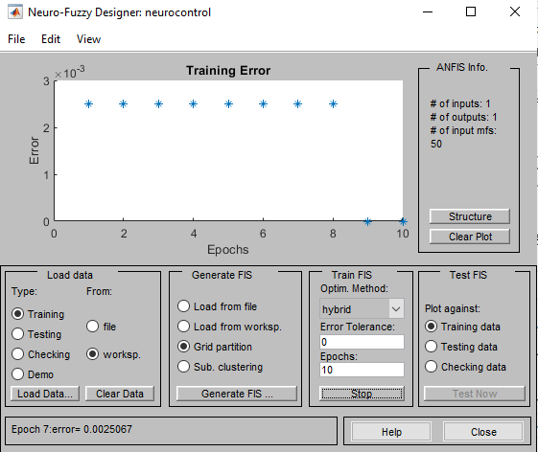
Figure 13. Training of membership functions in the Simulink® Matlab neuro-fuzzy designer (author's own work).

The associated neural network is shown in Figure 14, where an output and an input are analyzed. The links between the neurons are the weights corresponding to each fuzzy set. This is important because it allows the gains of the membership functions to be adapted according to the input data presented. This is something that no proportional control action could perform on its own.

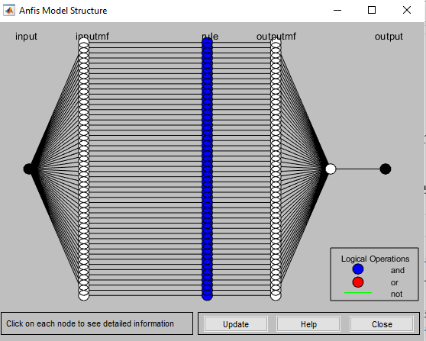
Figure 14. Neural network for the adaptive associated with the controller in the neuro-fuzzy assisted designer of Simulink Matlab, own elaboration.

- Results and discussions

Once the design procedure is completed, the training controller is replaced by a fuzzy controller, and the file obtained is loaded with the Neuro-Fuzzy Designer containing the membership functions and fuzzy rules as shown in Figure 15.

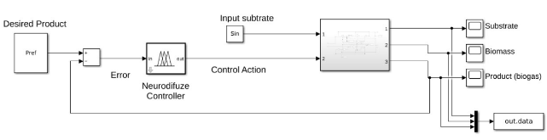
Figure 15. Batch reactor modeling in Simulink Matlab in closed loop applying neuro-fuzzy controller, own elaboration

Figure 16 shows the closed-loop dynamics of the substrate and biomass using an adaptive neuro-fuzzy controller with 50 delta-type (triangular) membership functions.

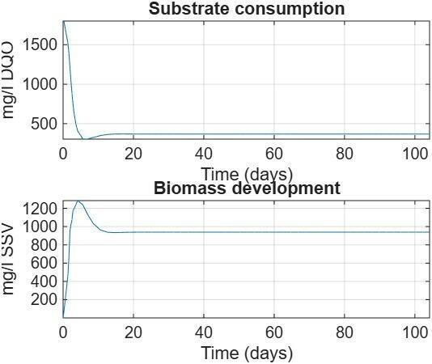
Figure 16. Dynamics of the closed-loop bioreactor (author's own work).

It is important to note that substrate consumption by the biomass reaches an equilibrium point around day 20, at which point biogas production ceases. This reduces the production of the same amount of biogas from the same amount of substrate by 70 days compared to the open-loop system. This production is shown in Figure 17.
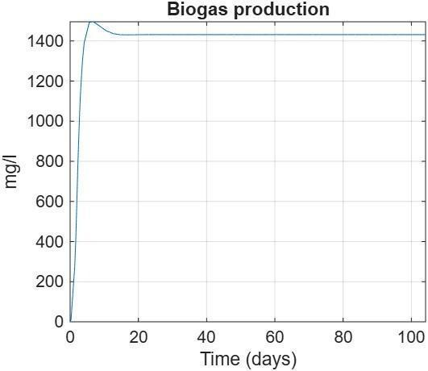
Figure 17. Closed-loop biogas production (author's own work).

The incorporation of an ANFIS-based neuro-fuzzy controller significantly accelerated the anaerobic digestion process and, consequently, biogas production in a batch-type biodigester. While the open-loop model reached biological equilibrium around day 90, the controlled system achieved an equivalent behavior approximately by day 20, reducing the production time by nearly 70 days. This result represents an improvement of more than 71% in process efficiency, demonstrating the controller’s capability to favorably modify the dynamics of microbial growth and substrate consumption.

Under neuro-fuzzy control, the biomass exhibited a substantially more efficient metabolic activity, consuming the available substrate within a considerably shorter period. This behavior indicates that the microorganisms operated closer to their optimal conditions, thereby enhancing the conversion of organic matter into methane and improving the energy recovery potential of organic waste.

The main innovation of this study lies in the application of hybrid artificial intelligence techniques to optimize biogas production in anaerobic biodigesters. Although numerous studies have focused on anaerobic digestion modeling, only a limited number integrate artificial neural networks and fuzzy logic simultaneously through an Adaptive Neuro-Fuzzy Inference System (ANFIS) specifically aimed at accelerating biogas generation. This combination exploits both the adaptive learning capability of machine learning techniques and the heuristic interpretability of expert knowledge, constituting an advanced strategy for the control of complex bioprocesses.

The controller training process provides evidence of the robustness of the proposed methodology. The achieved performance does not rely exclusively on a particular configuration but demonstrates significant methodological stability for future applications, considering that the controller was trained using a simple proportional control scheme as the initial reference. This finding indicates that, even from relatively simple control strategies, it is possible to generate knowledge capable of training intelligent systems that significantly outperform conventional controllers. The ANFIS architecture utilizes data obtained during simulation to automatically construct fuzzy rules and adjust membership functions, enabling continuous adaptation that cannot be achieved by a conventional proportional controller.

Table 1. Parameters used in the simulations.
Name | Symbol | Value | Units
Dilution factor | $$D$$ | 2.1E-6 | $$d^{-1}$$
Substrate in inlet stream | $$S_{i}$$ | 1800 | $$\frac{mg}{l} DQO$$
Biomass in inlet stream | $$X_{i}$$ | 0.1 | $$\frac{mg}{l} SSV$$
Performance coefficient | $$Y$$ | 3.35 | $$\frac{mg}{l} DQO$$
Sedimentation efficiency | $$η$$ | 0.5
Maximum velocity | $$μ_{max}$$ | 1.5E-5 | $$d^{-1}$$
Half-saturation constant | $$K$$ | 5522.3 | $$\frac{mg}{l} DQO$$
Desired production | $$P_{ref}$$ | 1440 | $$\frac{mg}{l}$$

4. Conclusions

The ANFIS controller developed in this study combines the learning capabilities of artificial neural networks with the linguistic interpretability of fuzzy logic, enabling the continuous adaptation of control actions according to the changing conditions of the process.

A particularly innovative aspect of this work is the demonstration that artificial intelligence can be employed not only to monitor process variables but also to actively modify the biological dynamics of the biodigester in order to reduce production times. From an industrial perspective, the reduction of approximately 70 days in the digestion process could translate into a substantial increase in productivity, improved reactor utilization, and enhanced economic profitability of biogas production facilities.

Furthermore, this research proposes a scalable methodology that can be extended to more complex models by incorporating critical process variables such as temperature, pH, pressure, and volatile fatty acid concentration. Since the current model considers only two primary variables (substrate and biomass), the obtained results should be regarded as a highly promising first approximation. The possibility of integrating additional variables and industrial sensors paves the way for the development of intelligent biodigesters capable of operating in real time under dynamically changing conditions.

This work represents a significant contribution to the field of bioprocess automation, demonstrating that modern artificial intelligence techniques can be applied to increase renewable energy production from organic waste. Such advancements have not only energy-related implications but also environmental benefits, including the promotion of urban waste valorization, the reduction of landfill disposal requirements, and support for the transition toward more sustainable circular economy models.

The obtained results demonstrate that the ANFIS neuro-fuzzy controller constitutes a highly effective strategy for enhancing the performance of anaerobic biodigesters, achieving substantial reductions in production time and process efficiency improvements exceeding 71%. The primary strength of this study lies in demonstrating that artificial intelligence can be utilized as a predictive and adaptive control tool for complex biological systems. Nevertheless, an important limitation remains: the reported results were obtained through mathematical simulation rather than experimental validation. Consequently, the next logical step is the implementation of the controller in a real biodigester equipped with industrial sensors for pH, temperature, pressure, and biogas flow rate monitoring. Such validation would enable confirmation of the technology's potential for industrial and commercial biomethane production applications.

- Authorship acknowledgements

Alfredo N. Torres Lopez: Conceptualization, methodology, investigation, resources, formal data analysis, validation, coordinated the experimental procedures, and original draft preparation. Rodrigo Cadena Martínez: Supervision, critically reviewed the manuscript for scientific accuracy, methodological consistency, formal analysis, project administration, review, and editing. Martha Hernández Ochoa: Formal analysis, data analysis, review, editing, writing, format, editorial coordination, including manuscript organization, and preparation according to the journal guidelines.

References

[1] A. Ishola, "Global renewable energy transition in fossil fuel dependent regions," World Journal of Advanced Research and Reviews, vol. 24, no. 1, pp. 1138–1373, 2024, doi: 10.30574/wjarr.2024.24.1.3046.
[2] G. Kataya, D. Cornu, M. Bechelany, A. Hijazi, and M. Issa, "Biomass waste conversion technologies and its application for sustainable environmental development—a review," Agronomy, vol. 13, no. 11, Art. no. 2833, 2023, doi: 10.3390/agronomy13112833.
[3] F. Ali et al., "Fueling the future: Biomass applications for green and sustainable energy," Discover Sustainability, vol. 5, no. 1, Art. no. 156, 2024, doi: 10.1007/s43621-024-00309-z.
[4] R. A. Verzijlbergh, L. J. de Vries, G. P. J. Dijkema, and P. M. Herder, "Institutional challenges caused by the integration of renewable energy sources in the European electricity sector," Renewable and Sustainable Energy Reviews, vol. 75, pp. 660–667, 2017, doi: 10.1016/j.rser.2016.11.039.
[5] F. Yang, J. C. Meerman, and A. P. C. Faaij, "Carbon capture and biomass in industry: A techno-economic analysis and comparison of negative emission options," Renewable and Sustainable Energy Reviews, vol. 144, Art. no. 111028, Jul. 2021, doi: 10.1016/j.rser.2021.111028.
[6] Q. Hassan et al., "The renewable energy role in the global energy transformations," Renewable Energy Focus, vol. 48, Art. no. 100545, 2024, doi: 10.1016/j.ref.2024.100545.
[7] A. Hussain, S. M. Arif, and M. Aslam, "Emerging renewable and sustainable energy technologies: State of the art," Renewable and Sustainable Energy Reviews, 2017, doi: 10.1016/j.rser.2016.12.033.
[8] T. Kalak, "Potential use of industrial biomass waste as a sustainable energy source in the future," Energies, vol. 16, no. 4, Art. no. 1783, 2023, doi: 10.3390/en16041783.
[9] A. Thakur, A. Kumar, and E. Berdimurodov, "Biomass Wastes," in Biomass Wastes for Sustainable Industrial Applications: A Waste-to-Wealth Approach. Boca Raton, FL, USA: CRC Press, 2024, doi: 10.1201/9781003466833-4.
[10] M. K. Jameel et al., "Biogas: Production, properties, applications, economic and challenges: A review," Results in Chemistry, vol. 7, Art. no. 101549, 2024, doi: 10.1016/j.rechem.2024.101549.
[11] M. J. B. Kabeyi, O. A. Olanrewaju, and J. Akpan, "Biogas production and process control improvements," in From Biomass to Biobased Products. Rijeka, Croatia: IntechOpen, 2024, doi: 10.5772/intechopen.113061.
[12] P. Satpathy, K. Wunder, M. Vaske, and S. Steinigeweg, "Converting sea weed to biogas energy: Utilization of synergism during co-digestion with maize silage," Energy Reports, vol. 8, pp. 1084–1093, Nov. 2022, doi: 10.1016/j.egyr.2022.11.002.
[13] S. V. Shah, B. Y. Lamba, A. K. Tiwari, and W.-H. Chen, "Sustainable biogas production via anaerobic digestion with focus on CSTR technology: A review," Journal of the Taiwan Institute of Chemical Engineers, vol. 162, Art. no. 105575, 2024, doi: 10.1016/j.jtice.2024.105575.
[14] E. A. Mekonen, Y. T. Mekonnen, and S. O. Fatoba, "Thermodynamic prediction of biogas production and combustion: The spontaneity and energy conversion efficiency from photosynthesis to combustion," Scientific African, vol. 21, Art. no. e01776, 2023, doi: 10.1016/j.sciaf.2023.e01776.
[15] A. Alengebawy, Y. Ran, A. I. Osman, K. Jin, M. Samer, and P. Ai, "Anaerobic digestion of agricultural waste for biogas production and sustainable bioenergy recovery: A review," Environmental Chemistry Letters, vol. 22, no. 6, pp. 2641–2668, 2024, doi: 10.1007/s10311-024-01789-1.
[16] C. E. Onu, C. N. Nweke, and J. T. Nwabanne, "Modeling of thermo-chemical pretreatment of yam peel substrate for biogas energy production: RSM, ANN, and ANFIS comparative approach," Applied Surface Science Advances, vol. 11, Oct. 2022, doi: 10.1016/j.apsadv.2022.100299.
[17] A. Wellinger, J. Murphy, and D. Baxter, Waste to Energy Conversion Technology. Cambridge, U.K.: Woodhead Publishing, 2013, doi: 10.1533/9780857097415.
[18] G. Gadirli, A. A. Pilarska, J. Dach, K. Pilarski, A. Kolasa-Więcek, and K. Borowiak, "Fundamentals, operation and global prospects for the development of biogas plants—A review," Energies, vol. 17, no. 3, Art. no. 568, 2024, doi: 10.3390/en17030568.
[19] C. Rosales-López, "Los bioprocesos en la biotecnología: Uso de biorreactores para la producción y el escalamiento de productos de interés comercial," Revista Tecnología en Marcha, Sep. 2019, doi: 10.18845/tm.v32i9.4626.
[20] F. A. Ortega Quintana, H. Álvarez, and H. A. Botero Castro, "Enfrentando el modelado de bioprocesos: Una revisión de las metodologías de modelado," Revista ION, vol. 30, no. 1, pp. 73–90, Jul. 2017, doi: 10.18273/revion.v30n1-2017006.
[21] V. L. Castillo, "Definición de bioprocesos: características y etapas," Enciclopedia.net, 2023. [Online]. Available: https://enciclopedia.net/bioprocesos/
[22] M. Khaleel, A. A. Ahmed, and A. Alsharif, "Artificial intelligence in engineering," Brilliance: Research of Artificial Intelligence, vol. 3, no. 1, pp. 32–42, 2023, doi: 10.47709/brilliance.v3i1.2170.
[23] W. Ertel, Introduction to Artificial Intelligence. Cham, Switzerland: Springer Nature, 2024, doi: 10.1007/978-3-658-43102-0.
[24] P. Ponce Cruz, Inteligencia Artificial: Con Aplicaciones a la Ingeniería, 2010. [Online]. Available: www.FreeLibros.me.
[25] R. Sissodia, M. S. Rauthan, V. Barthwal, and V. Dwivedi, "Fuzzy logic," in Recent Theories and Applications for Multi-Criteria Decision-Making. Hershey, PA, USA: IGI Global, 2024, p. 279, doi: 10.4018/979-8-3693-6502-1.ch010.
[26] R. Saatchi, "Fuzzy logic concepts, developments and implementation," Information, vol. 15, no. 10, Art. no. 656, 2024, doi: 10.3390/info15100656.
[27] A. Varshney and V. Goyal, "Re-evaluation on fuzzy logic-controlled system by optimizing the membership functions," Materials Today: Proceedings, 2023, doi: 10.1016/j.matpr.2023.03.799.
[28] MATLAB, "Introducción a las redes neuronales." [Online]. Available: https://la.mathworks.com/discovery/neural-network.html
[29] P. Viñuela and I. Galván, Redes de Neuronas Artificiales: Un Enfoque Práctico, 2004. [Online]. Available: http://sedici.unlp.edu.ar/handle/10915/9491
[30] P. E. Saw and E. Song, "RNA: An Introduction," in RNA Therapeutics in Human Diseases. Singapore: Springer, 2025, pp. 23–45, doi: 10.1007/978-981-96-3041-7.
[31] J. Matich, "Cátedra: Informática Aplicada a la Ingeniería de Procesos – Orientación I. Redes Neuronales: Conceptos Básicos y Aplicaciones," 2001. [Online]. Available: https://gc.scalahed.com/recursos/files/r161r/w25199w/s5_redesneuronales.pdf
[32] V. M. Gerardo Ortiz Gallardo, A. González Ortiz, R. Ortiz Eleveño, G. M. Gómez Alvarado, C. A. Torres de Loera, and E. G. Hernández Montoya, Diagnóstico Tecnológico CEMIE-Bio Clúster Biocombustibles Gaseosos 2. Fondo Sectorial CONACYT-SENER-Sustentabilidad Energética, 2017. [Online]. Available: https://www.gob.mx/cms/uploads/attachment/file/329892/Diagnostico_Tecnologico_BIOGAS_Final.pdf
[33] H. López-Aguilar, A. Barrón, M. Franco, A. Paz, and A. Pérez-Hernández, "Modelación de la generación de metano a partir de suero lácteo y excreta de ganado en codigestión anaerobia," Nova Scientia, vol. 13, no. 27, 2021, doi: 10.21640/ns.v13i27.2791.
[34] A. A. Flores Hernández, M. Flores Montiel, J. Reyes Reyes, and C. M. Astorga Zaragoza, "Diseño y modelado de un bioreactor tipo batch y continuo para aplicaciones de control automático," 2013. [Online]. Available: https://www.researchgate.net/publication/277312156_Diseno_y_modelado_de_un_bioreactor_tipo_batch_y_continuo_para_aplicaciones_de_control_automatico
[35] N. Aros, M. Cifuentes, and J. Mardones, "Modelación, simulación y control de procesos de fermentación," 2011. [Online]. Available: https://revistas.uta.cl/pdf/1761/art06.pdf
[36] L. Alba and M. Varela, "Dinámica de un Biorreactor con Modelo de Crecimiento de Bacterias Lineal por Tramos," 2011. [Online]. Available: https://bffrepositorio.unal.edu.co/server/api/core/bitstreams/8d933a18-60e6-4bd7-a3b8-0fdbbfc0fb9c/content
[37] S. Whitaker, R. Flores-Estrella, A. Estrada-Baltazar, R. Femat, and L. Potosí, "A Mathematical Model and Dynamic Analysis of Anaerobic Digestion of Soluble Organic Fraction of Municipal Solid Waste Towards Control Design," 2016. [Online]. Available: www.rmiq.org
[38] J. A. Laghari, "How To Design Adaptive Neuro Fuzzy Inference System in MATLAB/Simulink? (Part-2)," YouTube, 2021. [Online]. Available: https://www.youtube.com/watch?v=W_8IncyvhbI&list=PLgowgr9LiYjrVQV-GolT5GawUIt-5_ZP-&index=2

Derechos de Autor (c) 2026 Alfredo N. Torres López, Rodrigo Cadena Martínez, Martha Hernández Ochoa


Este texto está protegido por una licencia Creative Commons 4.0.

Usted es libre para compartir —copiar y redistribuir el material en cualquier medio o formato — y adaptar el documento —remezclar, transformar y crear a partir del material— para cualquier propósito, incluso para fines comerciales, siempre que cumpla la condición de:

Atribución: Usted debe dar crédito a la obra original de manera adecuada, proporcionar un enlace a la licencia, e indicar si se han realizado cambios. Puede hacerlo en cualquier forma razonable, pero no de forma tal que sugiera que tiene el apoyo del licenciante o lo recibe por el uso que hace de la obra.

Resumen de licencia - Texto completo de la licencia

